**CRE 245/1**

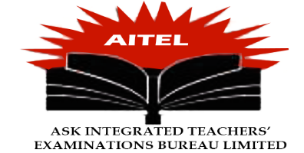

**AITEL PRE-REGISTRATION ASSESSMENTS**

**S.4 PRE-REGISTRATION ASESSMENT**

Instructions.

*Time: 2 hours*

*Attempt 3 questions from all*

*Choosing from both sections A & B*

*Finishing is compulsory.*

SECTION A

1a). Examine the inconsistences as found in the two creation stories. (12 mks).

b) Account for the occurrence of such inconsistences as found in the two creation stories.(13 mks)

2. Examine the major teachings that the creation stories in Genesis 1 and 2 give to their readers.

(12 mks)

b). How has man frustrated God’s plan for him? (13 mks)

3). To what extent is the New Testament Independent of the old testament? (25 mks).

4a).Justify Moses’s response to God the way he did. (13 mks)

b). Examine the role played by Moses in the Israelite society. (12 mks).

**SECTION B**

5a). Justify the View that the Exodus was a great land mark in the history of the Israelites.

(12 mks)

b). How is Jesus considered to be New Moses? (13 mks)

6a). Analyze the factors for the making of the covenant between God and the Israelites at Mt.Sinai

(12 mks)

b). Discuss the characteristics of the Sinai Covenant.

7a).Why was prophet Amos against the offering of Sacrifices? (12 Mks)

b) Under what Circumstances were the sacrifices of the isrealites accepted by God? (13mks)

8a).Examine the circumstances that surrounded the ordination ceremony of Aaron and his sons as priests in Leviticus 8 (13 mks)

b) Examine the significances of Priests among the Israelites in the Old Testament.

(12 mks)

**END**